# sync spencer code

|  |
| --- |
| mkdir spencer-sdk  repo init -u https://eureka-partner.googlesource.com/amlogic/manifest -b spencer-master -m combined_sdk.xml  repo sync  # Note:  # Some git are Google International only, so we cannot download them.  # And you will see some error message about "repo sync"  # If you want to skip it, you can remove it from "~/eureka/spencer-sdk/.repo/manifests/combined_sdk.xml".  --- a/combined_sdk.xml  +++ b/combined_sdk.xml  @@ -14,7 +14,5 @@  <project name="amlogic/lloyd-isp" path="lloyd-isp" revision="spencer-master"/>  <project name="verisilicon-sdk" path="verisilicon" revision="6.4.2"/>  <project name="amlogic/freertos" path="freertos" revision="spencer-master"/>  - <project name="amlogic/lloyd-proprietary-3a" path="lloyd-3a" revision="spencer-master"/>  - <project name="xtensa-tools" path="amlogic/xtensa" revision="master"/>  <project name="external/flatbuffers" path="amlogic/flatbuffers" revision="quartz-master"/>  </manifest> |

# 2、Build SDK

## 2.1 Bootloader (bl2 + bl31 + bl32 + u-boot)

|  |
| --- |
| # build without "release"，Default compilation option will enable logs.    cd ~/eureka/spencer-sdk/    cd bl2  ./build_bl2.sh spencer-p2 release  cd -    cd bl31  ./build_bl31.sh spencer-p2 release  cd -    cd bl32  ./build_bl32.sh spencer-p2 release  cd -    cd u-boot  ./build_uboot.sh spencer-p2 ./../../chrome release  cd - |

## 2.2 Kernel

|  |
| --- |
| cd ~/eureka/spencer-sdk/    cd kernel  ./build_kernel.sh spencer-p2 ./../../chrome  cd - |

## 2.3 Kernel module - NN

|  |
| --- |
| cd ~/eureka/spencer-sdk/    cd verisilicon  ./build_ml.sh arm64 spencer-p2 ./../../chrome  cd - |

## 2.4 Kernel module - ISP

|  |
| --- |
| cd ~/eureka/spencer-sdk/    cd lloyd-isp  ./build_isp.sh spencer-p2 ./../../chrome  cd - |

## 2.5 Kernel module - WIFI

|  |
| --- |
| cd ~/eureka/spencer-sdk/    cd dhd-driver  ./build_dhd.sh spencer-p2 ./../../chrome  cd - |

# 3.签名

Notes: 首先需要先获取到pdk编译脚本，这里以 spencer-p2 为例

## 3.1 签名u-boot

|  |
| --- |
| cd chrome/pdk  mkdir -p ../out/host/linux-x86/bin/  chrome$ tree out/host/  out/host/  └── linux-x86  └── bin  ├── kernel_iv.bin  ├── kernel_iv.txt  ├── mkbootimg  ├── pem_extract_pubkey.py  ├── sign-boot-g12a-dev.sh  └── sign-boot-g12a.sh  # 编译签名uboot  cd pdk  ./create-uboot.sh -b spencer-p2 |

编译结果

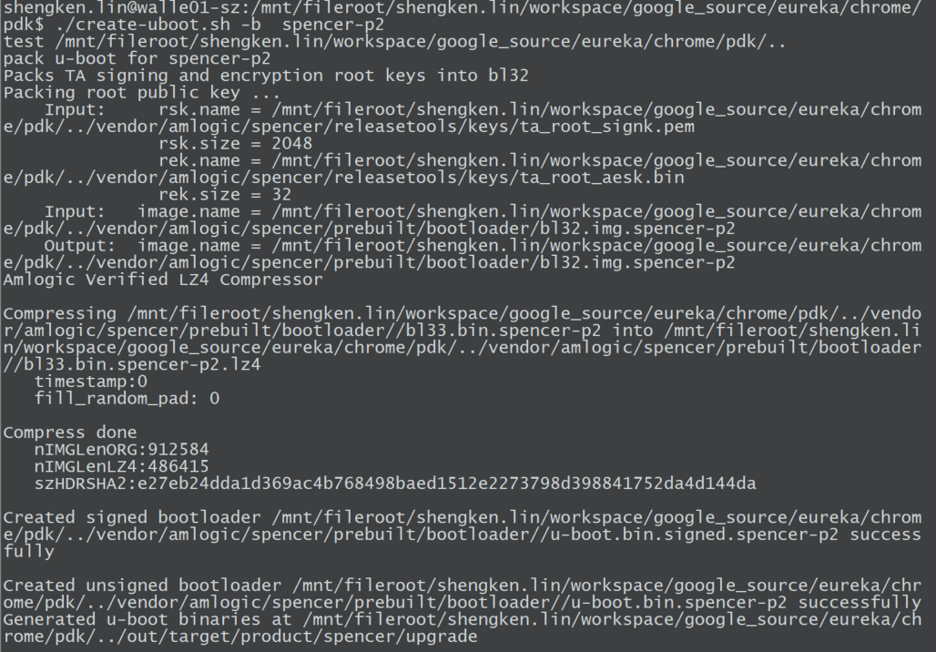

## 3.2 签名kernel

### 3.2.1 获取生成ramdisk

下载 ramdisk

<https://console.cloud.google.com/storage/browser/_details/cast-partner-amlogic-internal/internal/master/spencer-eng/314706/factory/spencer-fct-spencer-p2-314706.zip;tab=live_object>

解压后将 fct_boot.img 拷贝到 chrome/pdk/unpack_boot 目录下，

unpack_boot.sh ./fct_boot.img ./boot_out unpack_boot ## 注意修改脚本路径

cp ramdisk.img ../../chrome/out/target/product/spencer/boot_unpack/

## /mnt/fileroot/shengken.lin/workspace/google_source/eureka/chrome/pdk

./build-bootimg.sh -b spencer-p2

# 4、烧录

烧录路径

workspace/google_source/eureka/chrome/out/target/product/spencer/upgrade

烧录命令

|  |
| --- |
| adnl.exe  Download u-boot.signed.bin 0x10000  adnl.exe run  adnl.exe bl2_boot -F  u-boot.signed.bin  adnl.exe oem "store init 1"  adnl.exe oem "mmc dev 1"  adnl.exe Partition -M mem -P 0x1000000 -F spencer-p2.dtb  adnl.exe oem "emmc part_write 0x1000000"  adnl.exe  Partition -M mem -P 0x2000000 -F u-boot.signed.bin  adnl.exe oem "store boot_write bootloader 0x2000000 0x1ffe00"  adnl.exe Partition -P tpl_a  -F tpl.signed.bin  adnl.exe Partition -P tpl_b  -F tpl.signed.bin  adnl.exe Partition -P boot_a  -F boot.img  adnl.exe Partition -P boot_b  -F boot.img  adnl.exe Partition -P misc  -F misc.img  adnl.exe Partition -P system_b  -F fct_boot.img  adnl.exe oem "enable_factory_boot"  adnl.exe oem "reset" |